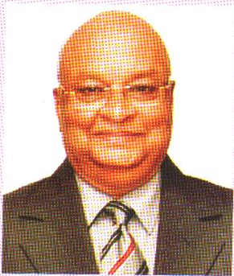

Profile of R. C. Mittal
Mittal Ramesh Chandra : an eminent Industrialist, and founder of Medi Caps Group, Born June 16, 1947; Education : B.Pharma from Sagar University (M.P.), Medi Caps Group have today emerged as one of the fastest growing group in Madhya Pradesh with diversified interest in Pharma Industry, Education, Capital Market and real estates, the group has rightfully claimed place as the leading Private organization in the state of M.P. and earned the reputation of being a “Group with a Difference”
Chariman cum Managing Director :
Medi Caps Limited – Indore an ISO-9001:2000 Company, unit of Manufacturing of Empty Hard Gelatine Capsules in India.
Medgel Private Ltd. - An US FDA Approved Soft Gelatin Plant.

Chairman & Managing Trustee : Medi Caps Charitable Trust, Medi Caps Education Society, Medi Caps Institute of Technology & Management, Medi Caps Institute of Science & Technology, Medi Caps Institute of Techno-Management - A prestigious educational institutes in M.P.
Director : Medi Caps IT Park Pvt. ltd., Mittal Cold Storage Pvt. Ltd.,
Member : Export Promation Council, The Indian Rose Federation, Red Cross Society of India, Indore Management Association, Pithampur Audyogik Sanghathan, Yashwant Club and an active member of many Clubs & Social Organizations.
Awards : Udyog Excellence Award- 1992, Glory of India International Award-1993, Order of Merit of Management -1994, Udyog Excellence Gold Medal -1994, * Vision & Mission of Life : Aspires to become a centre of Excellence, in the arena of Technical Education for professional advancement by providing the best technocrats & Management to the Society who can Aspire, Imagine, Act and Achieve for better life and better world. * Address : (off.) Medi Caps Limited, 201, Pushparatna Paradise, 9/5, New Palasia, In Front of UCO Bank, Indore- 452001. (Resi.) “Geet”, 1/5, New Palasia, Indore – 452001, India.
E-mail : Indore@medicaps.com Website: www.medicaps.com and www.medicaps-institute.ac.in

